**Final Project Plan**

**Company Name:** Bountiful Foods **Domain:** bountifulfood.org

**Site Purpose**

The purpose of bountifulfood.org will be to display information in relation to their organic, locally grown food as well as receive orders of specialized drinks depending on the customers desires. The website will consist of a home page to capture the attention of users interested in organic foods. The home page will be focused on providing relevant information to the user about the company, weather information of the location of the company, and social media links. The home page will provide navigation to three other pages (four pages in total). The first alternate page will consist of a form for the customer to be able to order a specialty drink from the company’s menu. The second alternate page will consist information about the company and contact information of the company. Finally, the last alternate page will consist of all the produce that the company provides to the user.

**Target Audience**

The target audience will consist of two types of users. The first type of user will be that of a company or restaurant that requires fresh ingredients to provide the best service to their customers. And the second user will be the local people of the area that desire fresh product for their homes and diet.   
  
**Scenarios**

Jesse Walker, the CEO of “Little Italian Restaurants” is a 45-year-old individual that has local business all around the area, in search of a company that can provide the freshest food products. This individual prefers local grown foods as it is easily accessible, does not require long shipping times, and stays as fresh as possible for their customers. If the company decides to expand, they would also want the option for the food to reach to long distant business as quickly as possible.

This user would be looking for companies from a company laptop or computer. The website will need to consist of simple, easy to read information to provide to this user to clearly let them know that this company is not just for individuals, but for corporations. With the ability to provide locally grown food in large quantities, but also using overseas produce will provide the needed information to this customer. Easy to access contact information will be crucial in this scenario.

Marie McConnor, a 35-year-old mother of 4 children and lives in the local area is looking elsewhere to find fresh produce to provide for her family. Many of the chemicals that is used with larger companies to preserve their produce is increasingly worrisome for her, and she desires food without the need of preservatives. She has also heard of the difficulty of local farmers in the area and wishes to assist them in buying their product, but is not sure where to look. This user would mainly look on her phone for information regarding fresh.

This user will be looking for easy to read simple information stating that the produce is locally grown and available without unneeded chemicals for their produce. For this type of user, it will be needed to provide an option to try the local produce by making specialty drinks for the user to decide if they like the produce and desire to order more for their home. List information will be needed incase the user desires to see the different produce provided by the company so they may order as desired for home use. All this information will need to be displayed with CSS driven design to help her navigate the home page through a mobile device.

**Site Map**

Specialty Drink!

International

Local/Domestic

About Us

Produce

homepage

**Color Scheme**

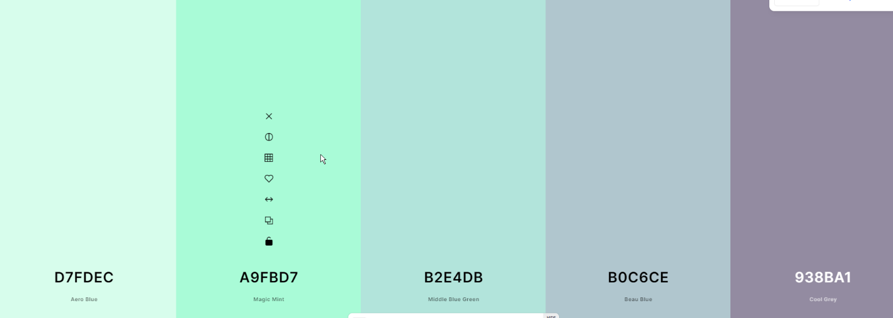

**Typography**